

**Submitted To**

**Mr. Suvendu Kumar Nayak**

Course Title: DATABASE CREATION AND MAINTENANCE

Course Code: CUTM1028(2-1-1)

**CENTURION UNIVERSITY OF TECHNOLOGY AND MANAGEMENTS**

**A Project Report**

**Submitted by**

Name: Kiran Kumar Malik

Registration no.: 200301120128

Semester: 2nd Sem

Section: C

Campus: Bhubaneswar

**In partial fulfilment for the award of the degree of B-Tech in Computer Science and Engineering’s**

**STUDENTS ADMISSION SYSTEM**

**Abstract**

An organized and systematic office solution is essential for all universities and organizations. There are many departments of administration for the maintenance of college information and student databases in any institution. All these departments provide various records regarding students. Most of these track records need to maintain information about the students. This information could be the general details like student name, address, performance, attendance etc or specific information related to departments like collection of data.

All the modules in college administration are interdependent. They are maintained manually. So, they need to be automated and centralized as, Information from one module will be needed by other modules. For example, when a student needs his course completion certificate it needs to check many details about the student like his name, reg number, year of study, exams he attended and many other details. So, it needs to contact all the modules that are office, department and examination and result of students.

With that in mind, we overhauled the existing Student Database Management System and made necessary improvement to streamline the processes. Administrators using the system will find that the process of recording and retrieving student’s information and managing their classes, including marking of attendance, is now a breeze. In general, this project aims to enhance efficiency and at the same time maintain information accurateness. Later in this report, features and improvement that allow achievement to this goal will be demonstrated and highlighted.

Our work is useful for easy user interface. We are planning to utilize the powerful database management, data retrieval and data manipulation. We will provide more ease for managing the data than manually maintaining in the documents. Our work is useful for saving valuable time and reduces the huge paper work.

|  |  |  |
| --- | --- | --- |
| **Sl.No.** | **Topic** | **Page no.** |
| 1 | Schema diagram of student admission database | 5 |
| 2 | ER Diagram of student admission database | 6 |
| 3 | Create Database | 8 |
| 4 | Create Table | 8-28 |
| 5 | Inserting data into the table Using INSERT INTO | 8-28 |
| 6 | Showing table using SELECT Statement | 8-28 |
| 7 | Using ALTER Command modify datatype | 9 |
| 8 | Using UPDATE Command with WHERE Clause | 8-28 |
| 9 | Insert data into a column using WHERE Clause | 8-28 |
| 10 | Update data in a column using UPDATE command with WHERE Clause | 8-28 |
| 11 | SELECT COMMAND WITHOUT DISTINCT | 30 |
| 12 | SELECT COMMAND WITH DISTINCT | 30 |
| 13 | Using AND Operator | 30 |
| 14 | Using OR Operator | 31 |
| 15 | Using NOT Operator | 31 |
| 16 | Combining AND, OR and NOT Operator | 31 |
| 17 | Using ORDER BY Keyword | 32 |
| 18 | Using ORDER BY DESC Keyword | 32 |
| 19 | Using NULL Operator | 32 |
| 20 | Using NOT NULL Operator | 32 |
| 21 | Using MIN() Function | 33 |
| 22 | Using MAX() Function | 33 |
| 23 | Using COUNT() Function | 33 |
| 24 | Using AVG() Function | 33 |
| 25 | Using SUM() Function | 34 |
| 26 | Using BETWEEN Operator | 34 |
| 27 | Using NOT BETWEEN Operator | 34 |
| 28 | Using UNION Operator | 35 |
| 29 | Using GROUP BY Statement | 35 |
| 30 | Using HAVING Clause | 35 |

**INDEX**

**Requirements Specifications**

**A Computer with:**

* Operating system: Windows, MacOS or Linux
* Processor: Pentium3, 32-bit
* RAM: 1.00 GB
* System type: 32-bit operating system, x32-based processor
* MySQL 8.0 Command Line Client
* Microsoft Office Word

Schema diagram of Student Admission Database

**USER:-**

|  |  |  |  |  |  |  |  |  |  |
| --- | --- | --- | --- | --- | --- | --- | --- | --- | --- |
| Name | Form_no. | Category_id | Course_id | Draft_no. | Contact_no. | Father’s_name | Sex | Address | Email |

**CATEGORY:-**

|  |  |  |  |
| --- | --- | --- | --- |
| Category_id | Category_name | Application_form_no. | Draft_no. |

**COURSE:-**

|  |  |  |  |
| --- | --- | --- | --- |
| Course_id | Course_name | Application_form_no. | Draft_no. |

**ELIGIBILITY CRITERIA:-**

|  |  |  |
| --- | --- | --- |
| Course_id | Category_id | Application_form_no. |

**ACADEMIC DETAILS:-**

|  |  |  |  |
| --- | --- | --- | --- |
| Application_form_no. | Name | Percentage | Exam_passed |

**PAYMENT DETAILS:-**

|  |  |  |  |  |
| --- | --- | --- | --- | --- |
| Application_form_no. | Draft_no | Course_id | Category_id | Payment_failed |

**ER Diagram of Student Admission database**

Course_id

Category_id

Course_name

Draft_no.

Application_form_no

Draft_no.

Application_form_no

Category_id

Category_name

Sex

Father’s_name

Contact no.

Form_no

Name

Course_id

Address

Payment_failed

Category_id

Category_id

Course_id

Draft_no.

Application_form_no

Course_id

Application_form_no

Exam_passed

Percentage

Name

Application_form_no

ACADEMIC DETAILS

Email

USER

APPLICATION FORM

CATEGORY

ELIGIBILITY CRITERIA

PAYMENT DETAILS

COURSE

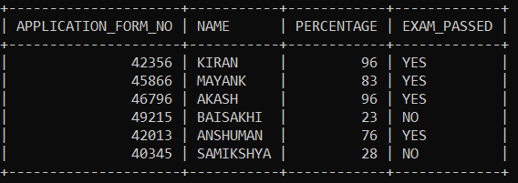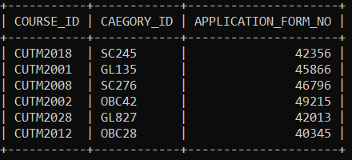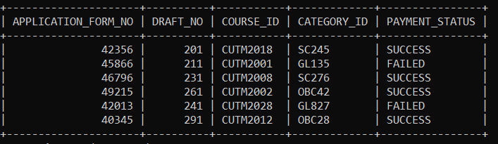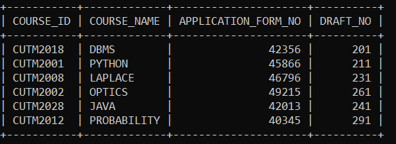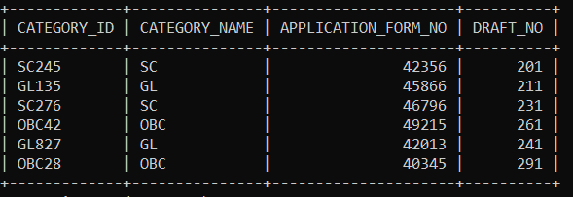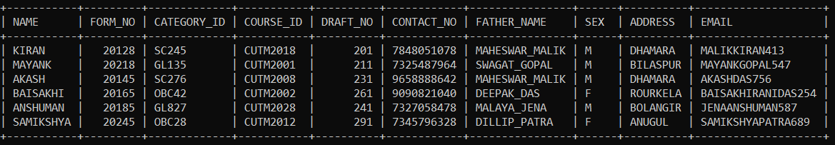

**ACADEMIC DETAILS Table**

**PAYMENT DETAILS Table**

**ELIGIBILITY CRITERIA Table**

**COURSE Table**

**CATEGORY Table**

**USER Table**

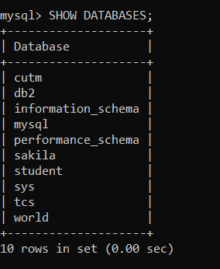SHOW DATABASES;

USE STUDENT;



**CREATING USER TABLE**

CREATE TABLE USER(NAME VARCHAR(20),FORM_NO INT,CATEGORY_ID VARCHAR(5),COURSE_ID VARCHAR(9),DRAFT_NO INT,CONTACT_NO INT,FATHER_NAME VARCHAR(20),SEX CHAR,ADDRESS VARCHAR(40),EMAIL VARCHAR(20));

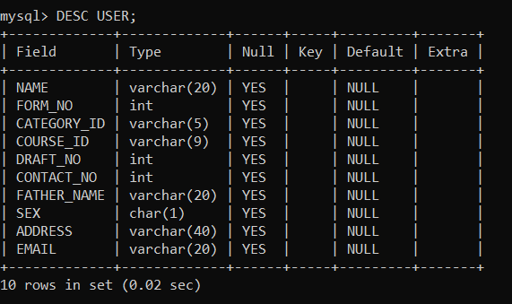DESC USER;

**Modify datatype**

ALTER TABLE USER MODIFY CONTACT_NO VARCHAR(10);

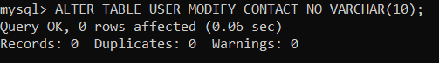

DESC USER;

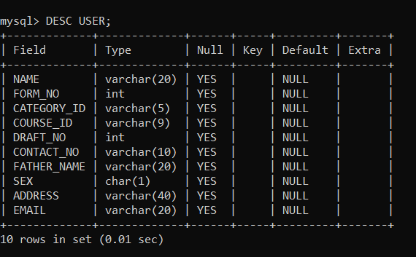

**INSERTING DATA INTO THE TABLE (INSERT INTO Statement)**

INSERT INTO USER VALUES('KIRAN', '20128', 'SC', 'CUTM2018', 201, '7848051078', 'MAHESWAR_MALIK', 'M', 'DHAMARA', 'MALIKKIRAN413');

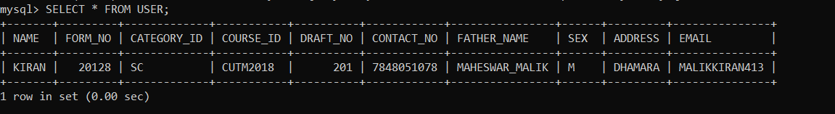SELECT * FROM USER;

INSERT INTO USER VALUES('MAYANK', '20218', 'GL', 'CUTM2001', 211, '7325487964', 'SWAGAT_GOPAL', 'M', 'BILASPUR', 'MAYANKGOPAL547');

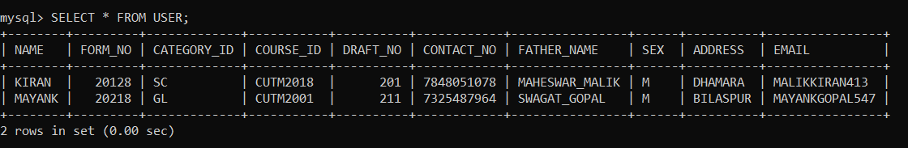SELECT * FROM USER;

INSERT INTO USER VALUES('AKASH', '20145', 'SC', 'CUTM2018', 231, '9658888642', 'MAHESWAR_MALIK', 'M', 'DHAMARA', 'AKASHDAS756');

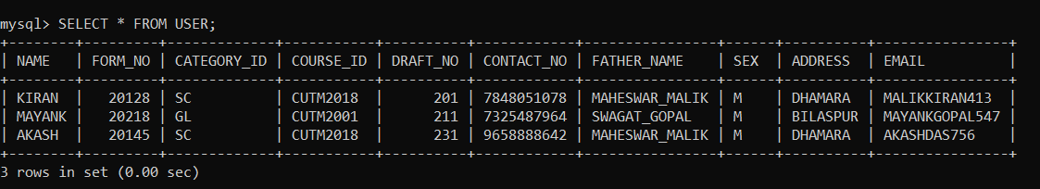SELECT * FROM USER;

INSERT INTO USER VALUES('BAISAKHI', '20165', 'OBC', 'CUTM2002', 261, '9090821040', 'DEEPAK_DAS', 'F', 'ROURKELA', 'BAISAKHIRANIDAS254');

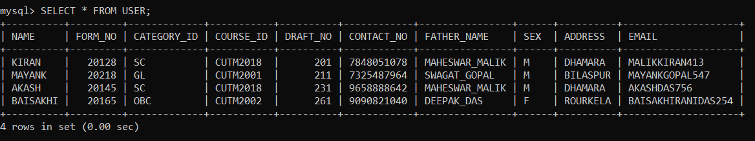SELECT * FROM USER;

INSERT INTO USER VALUES('ANSHUMAN', '20185', 'GL', 'CUTM2001', 241, '7327058478', 'MALAYA_JENA', 'M', 'BOLANGIR', 'JENAANSHUMAN587');

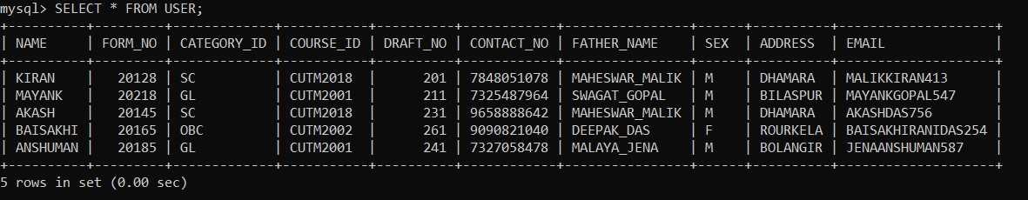SELECT * FROM USER;

INSERT INTO USER VALUES('SAMIKSHYA', '20245', 'OBC', 'CUTM2002', 291, '7345796328', 'DILLIP_PATRA', 'F', 'ANUGUL', 'SAMIKSHYAPATRA689');

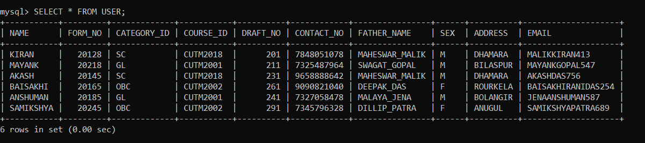SELECT * FROM USER;

**UPDATING THE DATA BY SPECIFYING A COLUMN OF PARTICULAR TUPLE USING WHERE CLAUSE (UPDATE Statement)**

UPDATE USER SET CATEGORY_ID='SC245' WHERE NAME='KIRAN';

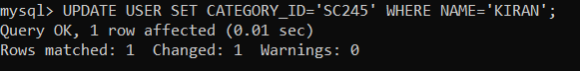

SELECT * FROM USER;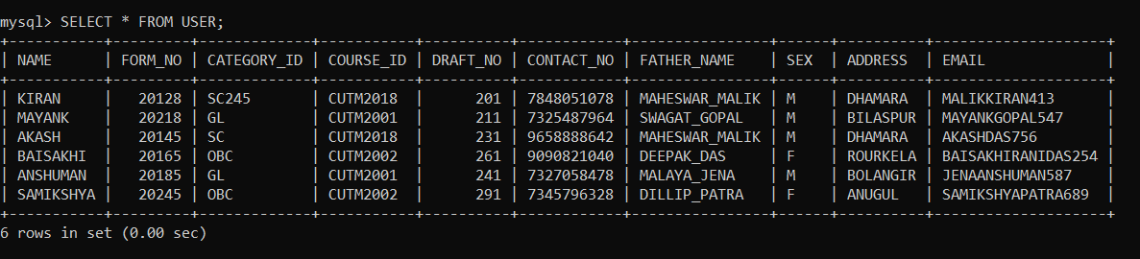

UPDATE USER SET CATEGORY_ID='GL135' WHERE NAME='MAYANK';

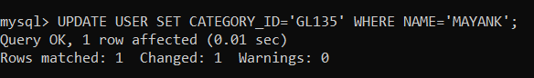

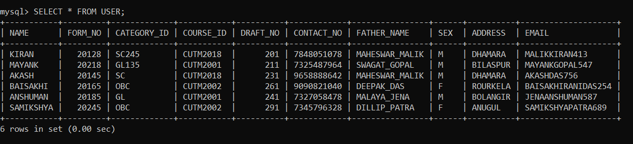SELECT * FROM USER;

UPDATE USER SET CATEGORY_ID='SC276' WHERE NAME='AKASH';

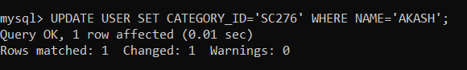

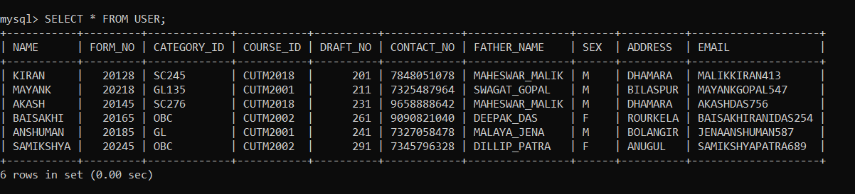SELECT * FROM USER;

UPDATE USER SET CATEGORY_ID='OBC42' WHERE NAME='BAISAKHI';

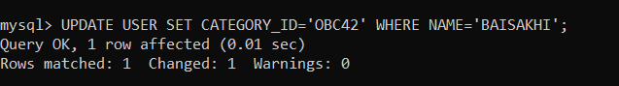

SELECT * FROM USER;

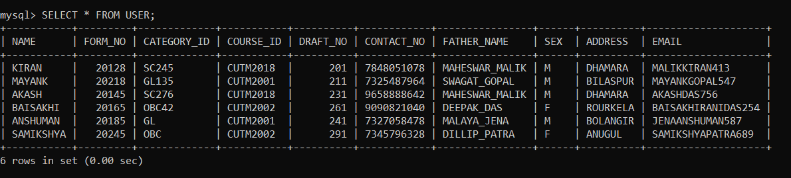

UPDATE USER SET CATEGORY_ID='GL827' WHERE NAME='ANSHUMAN';

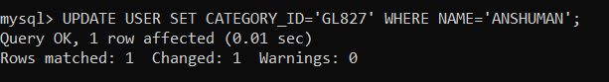

SELECT * FROM USER;

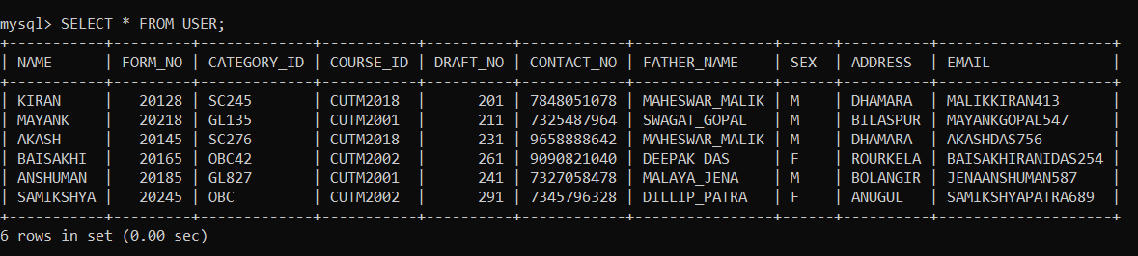

UPDATE USER SET CATEGORY_ID='OBC28' WHERE NAME='SAMIKSHYA';

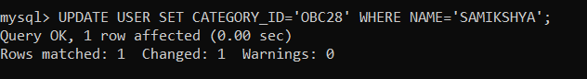

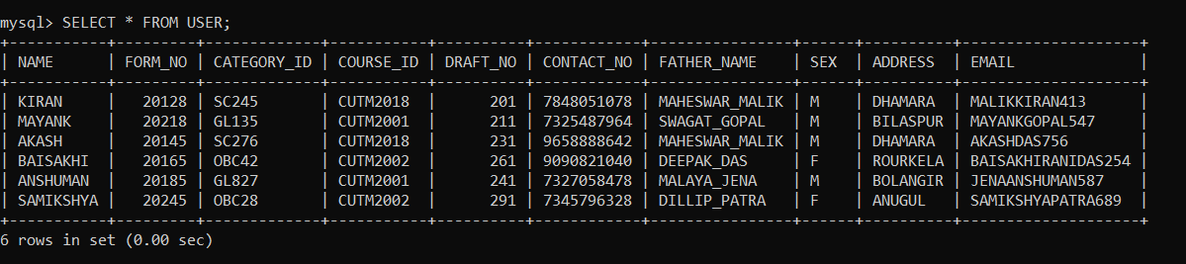SELECT * FROM USER;

**CREATING CATEGORY TABLE:**

CREATE TABLE CATEGORY(CATEGORY_ID VARCHAR(5),CATEGORY_NAME VARCHAR(10),APPLICATION_FORM_NO INT,DRAFT_NO INT);

DESC CATEGORY;

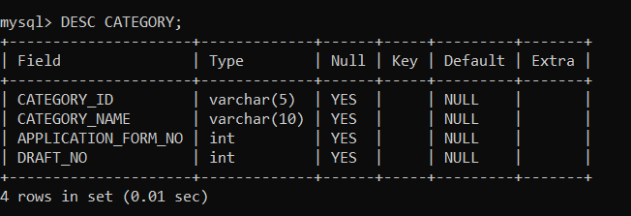

**INSERTING DATA INTO THE TABLE (INSERT INTO Statement)**

INSERT INTO CATEGORY VALUES('SC245', 'SC','42356', '201');



SELECT * FROM CATEGORY;

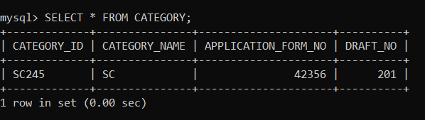

INSERT INTO CATEGORY VALUES('GL135', 'GL','45866', '211');



SELECT * FROM CATEGORY;

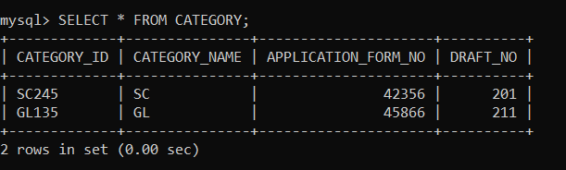

INSERT INTO CATEGORY VALUES('SC276', 'SC','46796', '231');



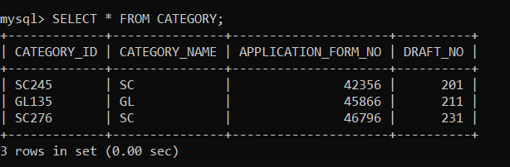SELECT * FROM CATEGORY;

INSERT INTO CATEGORY VALUES('OBC42', 'OBC','49215', '261');



SELECT * FROM CATEGORY;

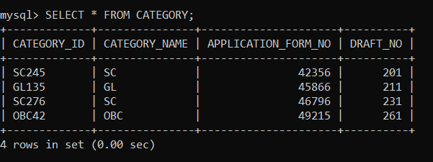

INSERT INTO CATEGORY VALUES('GL827', 'GL','42013', '241');



SELECT * FROM CATEGORY;

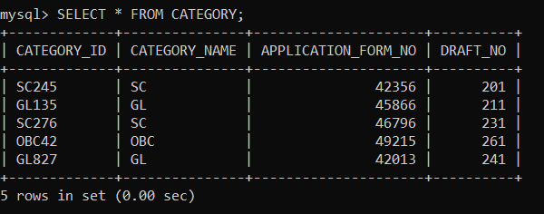

INSERT INTO CATEGORY VALUES('OBC28', 'OBC','40345', '291');



SELECT * FROM CATEGORY;

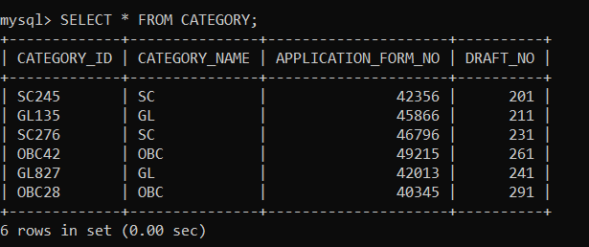

**CREATING COURSE TABLE**

CREATE TABLE COURSE(COURSE_ID VARCHAR(5),COURSE_NAME VARCHAR(20),APPLICATION_FORM_NO INT,DRAFT_NO INT);

DESC COURSE;

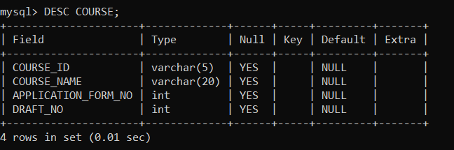

ALTER TABLE COURSE MODIFY COURSE_ID VARCHAR(10);

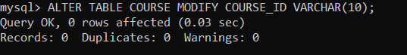

DESC COURSE;

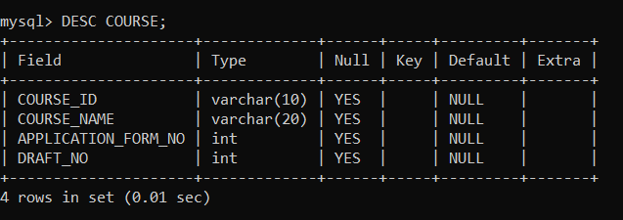

**INSERTING DATA INTO THE TABLE (INSERT INTO Statement)**

INSERT INTO COURSE VALUES('CUTM2018', 'DBMS','42356', '201');

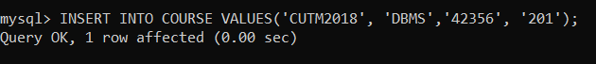

SELECT * FROM COURSE;

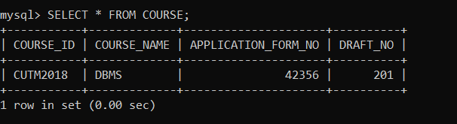

INSERT INTO COURSE VALUES('CUTM2001', 'PYTHON','45866', '211');



SELECT * FROM COURSE;

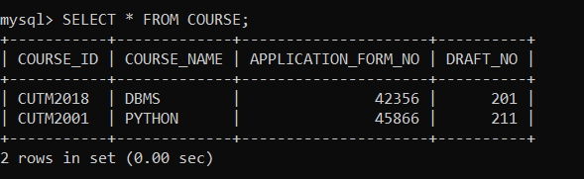

INSERT INTO COURSE VALUES('CUTM2008', 'LAPLACE','46796', '231');



SELECT * FROM COURSE;

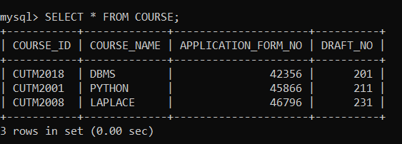

INSERT INTO COURSE VALUES('CUTM2002', 'OPTICS','49215', '261');



SELECT * FROM COURSE;

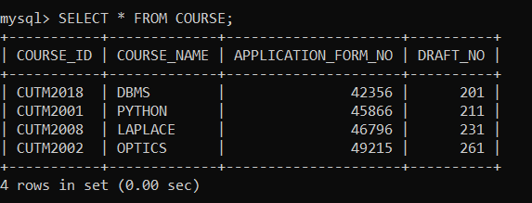

INSERT INTO COURSE VALUES('CUTM2028', 'JAVA','42013', '241');

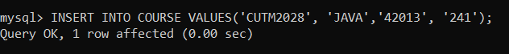

SELECT * FROM COURSE;

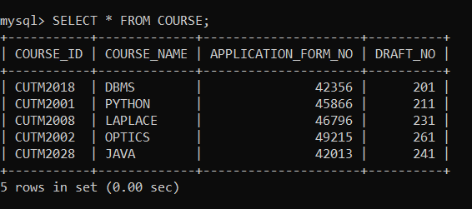

INSERT INTO COURSE VALUES('CUTM2012', 'PROBABILITY','40345', '291');



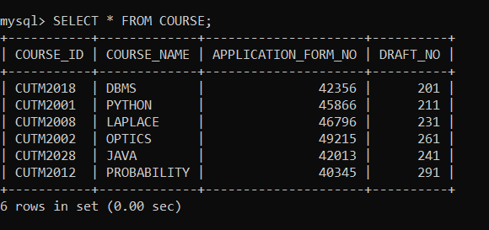SELECT * FROM COURSE;

**CREATING ELIGIBILITY CRITERIA TABLE**

CREATE TABLE ELIGIBILITY_CRITERIA(COURSE_ID VARCHAR(10),CAEGORY_ID VARCHAR(10),APPLICATION_FORM_NO INT);

DESC ELIGIBILITY_CRITERIA;

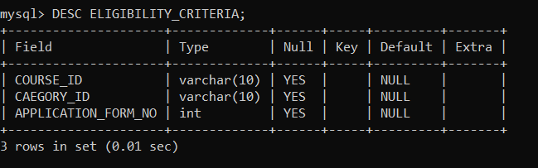

**INSERTING DATA INTO TABLE BY EXTRACTING THE DATA FROM OTHER TABLE (INSERT INTO Statement)**

INSERT INTO ELIGIBILITY_CRITERIA(COURSE_ID,CATEGORY_ID) SELECT COURSE_ID,CATEGORY_ID FROM USER;

SELECT * FROM ELIGIBILITY_CRITERIA;

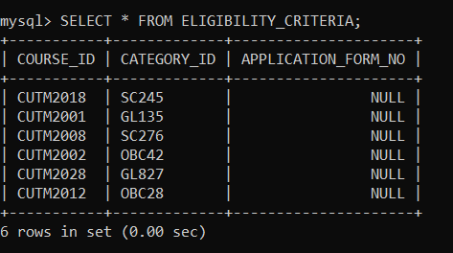

**INSERTING DATA INTO A COLUMN OF PARTICULAR TUPLE USING WHERE CLAUSE**

UPDATE ELIGIBILITY_CRITERIA SET APPLICATION_FORM_NO='42356' WHERE COURSE_ID='CUTM2018';

UPDATE ELIGIBILITY_CRITERIA SET APPLICATION_FORM_NO='45866' WHERE COURSE_ID='CUTM2001';

UPDATE ELIGIBILITY_CRITERIA SET APPLICATION_FORM_NO='46796' WHERE COURSE_ID='CUTM2008';

UPDATE ELIGIBILITY_CRITERIA SET APPLICATION_FORM_NO='49215' WHERE COURSE_ID='CUTM2002';

UPDATE ELIGIBILITY_CRITERIA SET APPLICATION_FORM_NO='42013' WHERE COURSE_ID='CUTM2028';

UPDATE ELIGIBILITY_CRITERIA SET APPLICATION_FORM_NO='40345' WHERE COURSE_ID='CUTM2012';

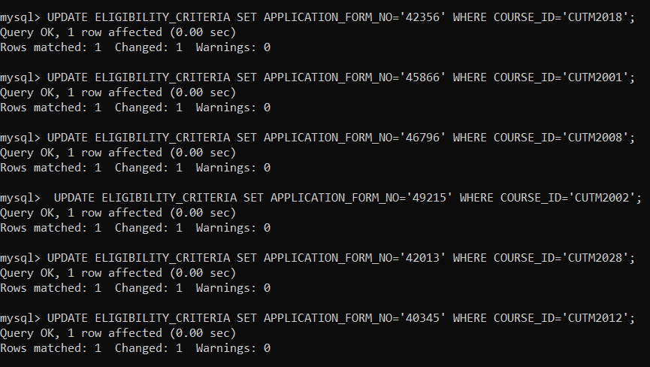

SELECT * FROM ELIGIBILITY_CRITERIA;

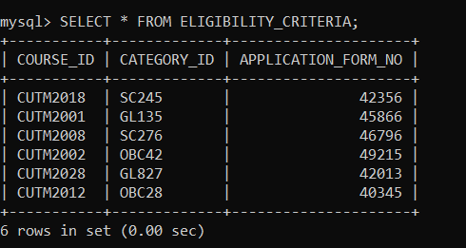

**CREATING ACADEMIC DETAILS TABLE**

CREATE TABLE ACADEMIC_DETAILS(APPLICATION_FORM_NO INT,NAME VARCHAR(20),PERCENTAGE DECIMAL,EXAM_PASSED VARCHAR(3));

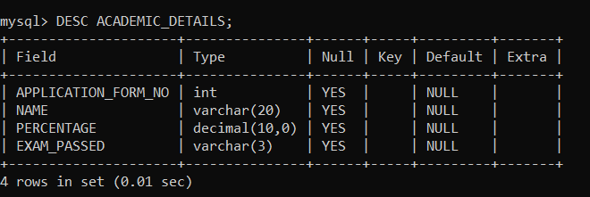DESC ACADEMIC_DETAILS;

**INSERTING DATA INTO ACADEMIC DETAILS TABLE**

**(INSERT INTO Statement)**

INSERT INTO ACADEMIC_DETAILS VALUES('42356', 'KIRAN', '96.45', 'YES');

SELECT * FROM ACADEMIC_DETAILS;

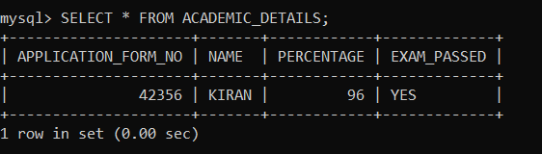

INSERT INTO ACADEMIC_DETAILS VALUES('45866', 'MAYANK', '82.76', 'YES');

SELECT * FROM ACADEMIC_DETAILS;

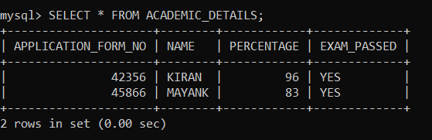

INSERT INTO ACADEMIC_DETAILS VALUES('46796', 'AKASH', '96.45', 'YES');

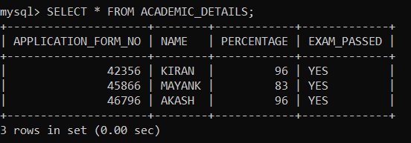SELECT * FROM ACADEMIC_DETAILS;

INSERT INTO ACADEMIC_DETAILS VALUES('49215', 'BAISAKHI', '23.49', 'NO');

SELECT * FROM ACADEMIC_DETAILS;

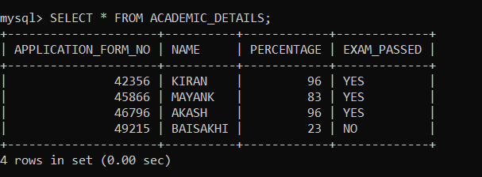

INSERT INTO ACADEMIC_DETAILS VALUES('42013', 'ANSHUMAN', '76.18', 'YES');



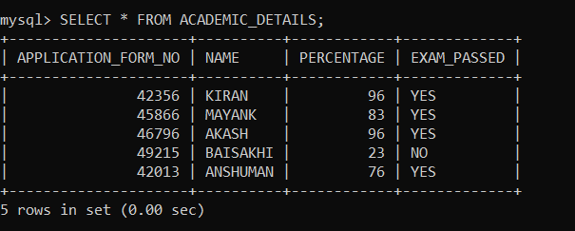SELECT * FROM ACADEMIC_DETAILS;

INSERT INTO ACADEMIC_DETAILS VALUES('40345', 'SAMIKSHYA', '27.94', 'NO');

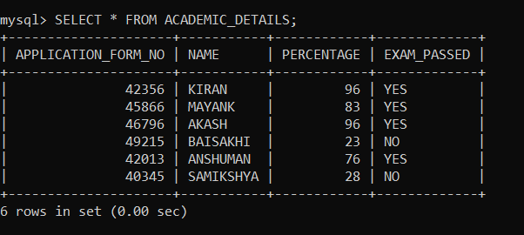SELECT * FROM ACADEMIC_DETAILS;

**CREATING PAYMENT DETAILS TABLE**

CREATE TABLE PAYMENT_DETAILS(APPLICATION_FORM_NO INT,DRAFT_NO INT,COURSE_ID VARCHAR(10),CATEGORY_ID VARCHAR(5),PAYMENT_STATUS VARCHAR(10));

DESC PAYMENT_DETAILS;

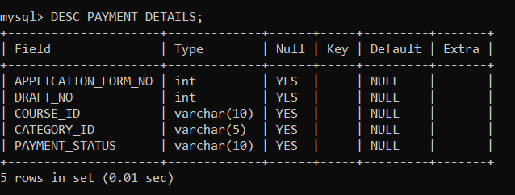

**INSERTING DATA INTO PAYMENT DETAILS TABLE (INSERT INTO Statement)**

INSERT INTO PAYMENT_DETAILS VALUES('42356', '201', 'CUTM2018', 'SC245', 'SUCESS');

SELECT * FROM PAYMENT_DETAILS;

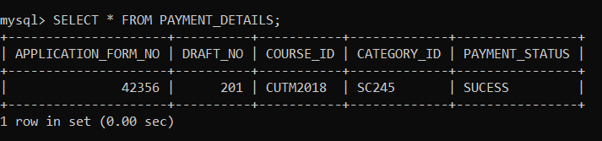

INSERT INTO PAYMENT_DETAILS VALUES('45866', '211', 'CUTM2001', 'GL135', 'FAILED');

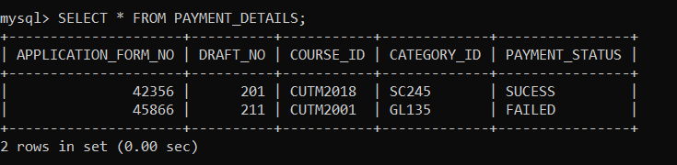SELECT * FROM PAYMENT_DETAILS;

INSERT INTO PAYMENT_DETAILS VALUES('46796', '231', 'CUTM2008', 'SC276', 'SUCCESS');

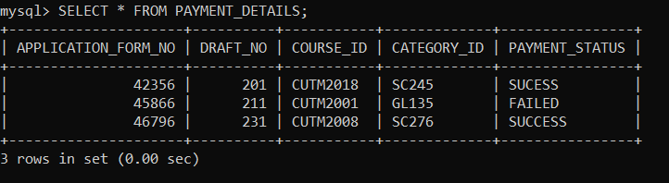SELECT * FROM PAYMENT_DETAILS;

**UPDATING DATA IN PATICULAR COLUMN OF A TUPLE (UPDATE Statement)**

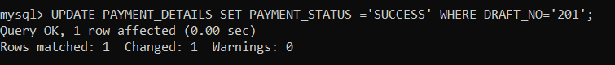UPDATE PAYMENT_DETAILS SET PAYMENT_STATUS ='SUCCESS' WHERE DRAFT_NO='201';

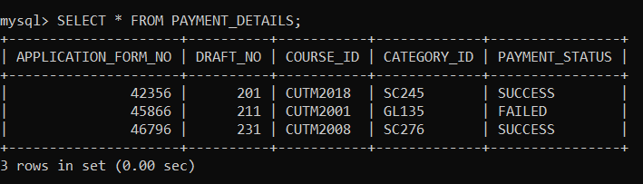SELECT * FROM PAYMENT_DETAILS;

INSERT INTO PAYMENT_DETAILS VALUES('49215', '261', 'CUTM2002', 'OBC42', 'SUCCESS');

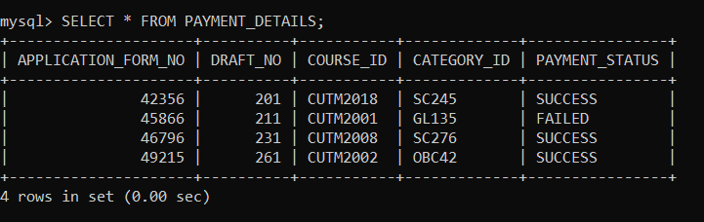SELECT * FROM PAYMENT_DETAILS;

INSERT INTO PAYMENT_DETAILS VALUES('42013', '241', 'CUTM2028', 'GL827', 'FAILED');



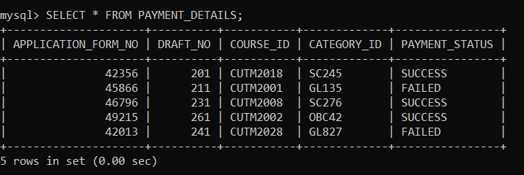SELECT * FROM PAYMENT_DETAILS;

INSERT INTO PAYMENT_DETAILS VALUES('40345', '291', 'CUTM2012', 'OBC28', 'SUCCESS');

SELECT * FROM PAYMENT_DETAILS;

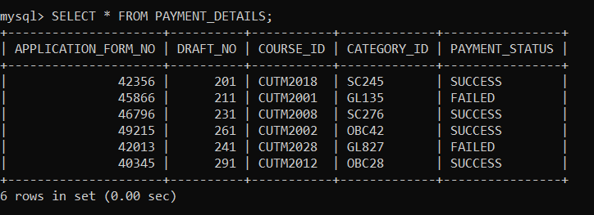

**SELECT STATEMENT WITHOUT DISTINCT**

SELECT NAME,FATHER_NAME FROM USER;

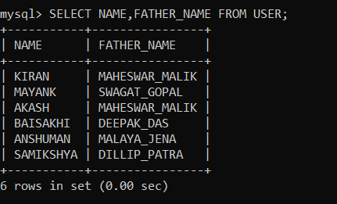

**SELECT STATEMENT WITH DISTINCT**

SELECT DISTINCT FATHER_NAME,ADDRESS FROM USER;

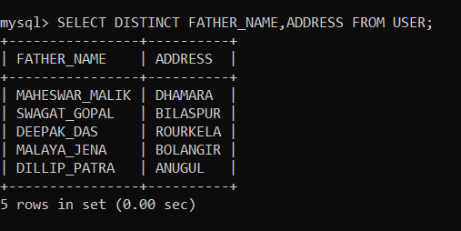

**Using AND, OR and NOT OPERATOR**

**Using AND Operator**

SELECT * FROM ACADEMIC_DETAILS WHERE NAME='KIRAN' AND EXAM_PASSED='YES';

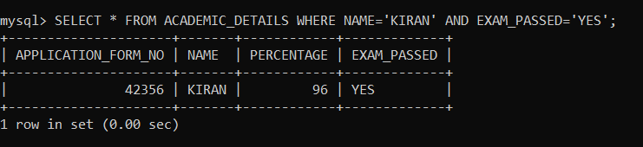

**Using OR Operator**

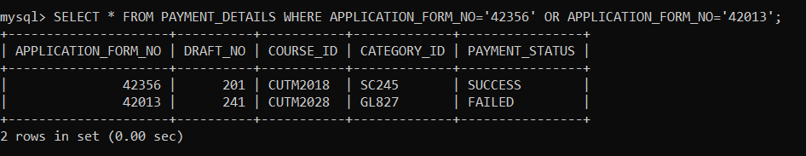SELECT * FROM PAYMENT_DETAILS WHERE APPLICATION_FORM_NO='42356' OR APPLICATION_FORM_NO='42013';

**Using NOT Operator**

SELECT * FROM ACADEMIC_DETAILS WHERE NOT NAME='BAISAKHI';

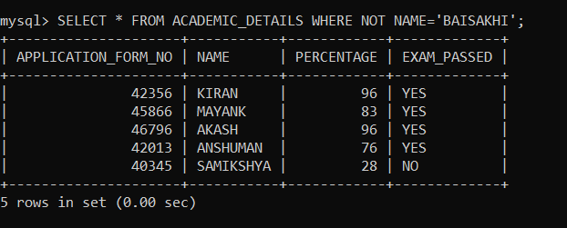

**Combining AND, OR and NOT Operator**

SELECT * FROM USER WHERE FATHER_NAME='MAHESWAR_MALIK' AND (NAME='KIRAN' OR NAME='AKASH');

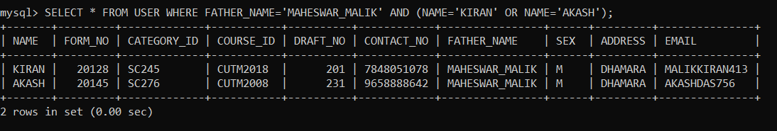

SELECT * FROM USER WHERE NOT NAME='BAISAKHI' AND NOT NAME='SAMIKSHYA';

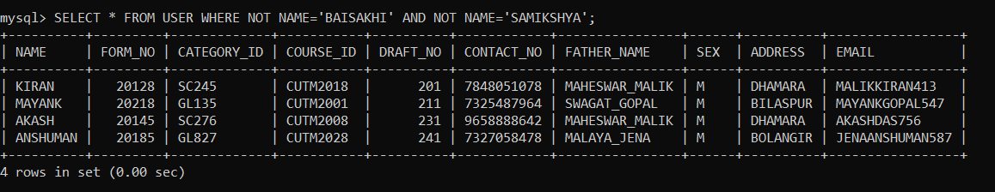

**Using ORDER BY Keyword**

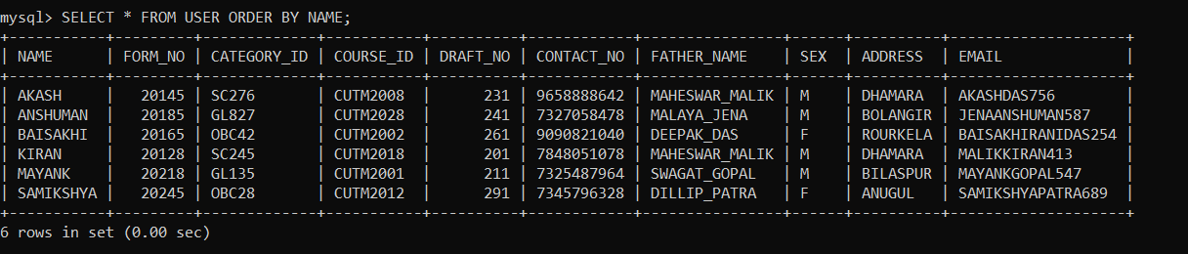SELECT * FROM USER ORDER BY NAME;

**Using ORDER BY DESC Keyword**

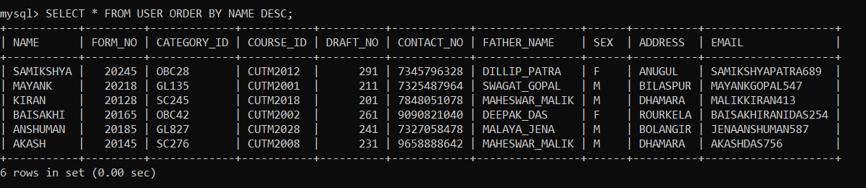SELECT * FROM USER ORDER BY NAME DESC;

**Using NULL Operator**

SELECT * FROM ELIGIBILITY_CRITERIA WHERE CATEGORY_ID IS NULL;



**Using NOT NULL Operator**

SELECT * FROM ELIGIBILITY_CRITERIA WHERE CATEGORY_ID IS NOT NULL;

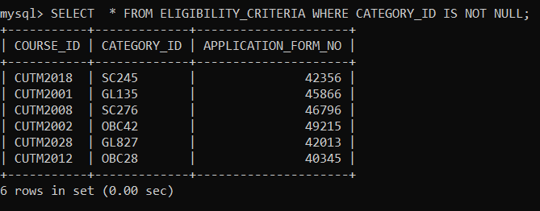

**Using MIN() and MAX() Function**

**Using MIN() Function**

SELECT MIN(PERCENTAGE) FROM ACADEMIC_DETAILS;

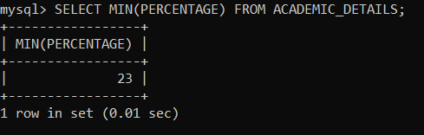

**Using MAX() Function**

SELECT MAX(PERCENTAGE) FROM ACADEMIC_DETAILS;

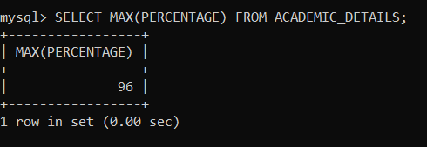

**Using COUNT(), AVG() and SUM() Function**

**Using COUNT() Function**

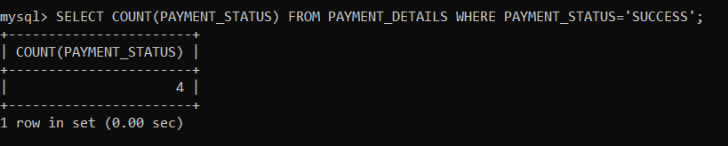SELECT COUNT(PAYMENT_STATUS) FROM PAYMENT_DETAILS WHERE PAYMENT_STATUS='SUCCESS';

**Using AVG() Function**

SELECT AVG(PAYMENT_STATUS) FROM PAYMENT_DETAILS WHERE PAYMENT_STATUS='SUCCESS';

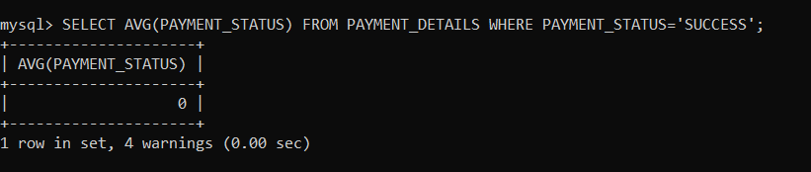

**Using SUM() Function**

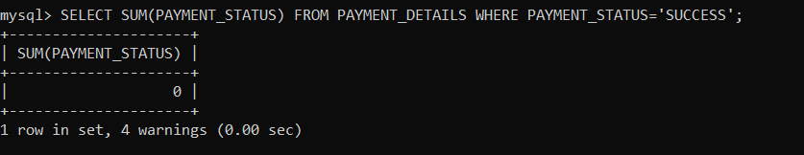SELECT SUM(PAYMENT_STATUS) FROM PAYMENT_DETAILS WHERE PAYMENT_STATUS='SUCCESS';

**Using BETWEEN Operator**

SELECT * FROM ACADEMIC_DETAILS WHERE PERCENTAGE BETWEEN 75 AND 100;

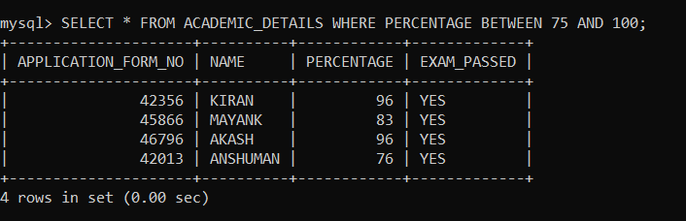

**Using NOT BETWEEN Operator**

SELECT * FROM ACADEMIC_DETAILS WHERE PERCENTAGE NOT BETWEEN 75 AND 100;

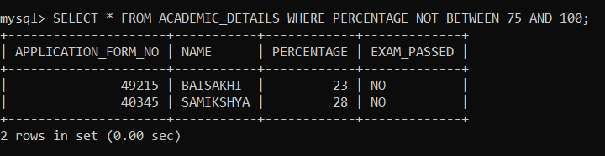

**Using UNION Operator**

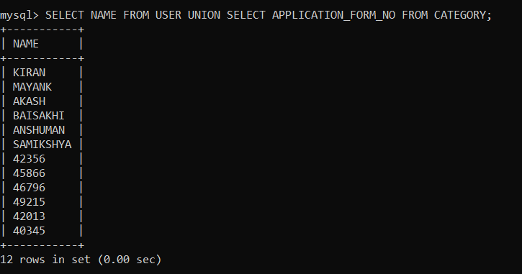SELECT NAME FROM USER UNION SELECT APPLICATION_FORM_NO FROM CATEGORY;

**Using GROUP BY Statement**

SELECT COUNT(DRAFT_NO), FATHER_NAME FROM USER GROUP BY FATHER_NAME;

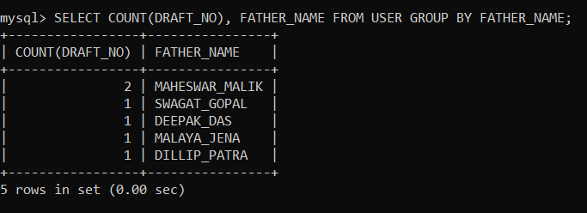

**Using HAVING Clause**

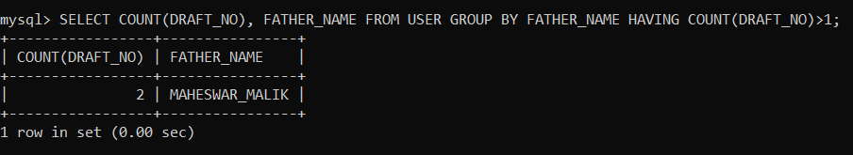SELECT COUNT(DRAFT_NO), FATHER_NAME FROM USER GROUP BY FATHER_NAME HAVING COUNT(DRAFT_NO)>1;

**Conclusion**

Student Admission Management System are being identified as an appropriate method for managing information in university. SMS was built based on real life situation in Centurion University, taking into consideration all possible situations and functionalities of the daily work in these school. This system considered as a good first in implementing performing online based information management in university.

**References**

1. [**https://www.w3schools.com/sql/default.asp**](https://www.w3schools.com/sql/default.asp)
2. **Fundamentals of Database Systems 7th Edition by Elmasri.Navathe**
3. **Principles of Engineering Physics-2 by Md.Khan, S.Panigrahi, Cambridge University Press 2016. [module-V, VI&VII]**